**Chapter 10 From Hominoid to Hominin**

**Adam Purvis**

**Hominins**

- cooling + climate of the Earth led to the evolution of Hominins

- End of Miocene - Cooling, less rain, rain seasonality, woodland and savannah spread

- Appeared approximately six million years ago

**What is unique about Hominins?**

- Bipedalism 🡪 led to major morphological changes

- Small canines, large molars, thick enamel

- Large brains

- Slow life histories, long juvenile period

- Language, walk, talk, symbolic culture

**What does it take to be a Biped?**

- Hominoids to Hominins - Many new adaptations

- Human pelvis is different from forest-dwelling apes like the chimp.

- Torque - created by a twisting force from pelvis

- Torso does not tip due to abductor muscles that run from outer side of pelvis to the femur 🡪 Abductors are attached to the ilium.

- Lengthening neck of femur add to leverage that he abductors can exert and make bipedal walking more efficient

- Knee joint much more complex

- Feet 🡪 non-grasping big toes and arches

**First Hominin**

- First Hominin discovered between 7 to 5 mya 🡪 *Sahelanthropus tchadensis*

- Has derived and ancestral traits

- Chimpanzee sized brain, shares many traits with chimpanzees

- Small canines

- Flat face, large browridge

**Foramen Magnum**

- Hole in the skull through which the spinal cord passes, suggests bipedal locomotion

***Orrorin tugenensis***

- Dated to 6 mya, found in Kenya

- Also similar to chimps 🡪 incisors, canines, premolar

- But also similar to humans 🡪 Smaller molars, thicker enamel, larger thigh bones

- More human-like than ape-like

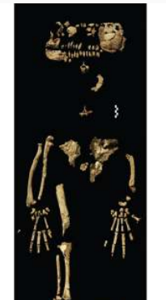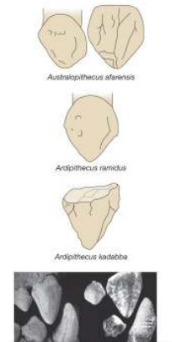***Ardipithecus***

- Found in Ethiopia 🡪 dry conditions very nice for fossils

**A. ramidus**

- 4.4 mya 🡪 fossils in very poor condition

- Lived in a woodland habitat

- Bipedal; climber; small brain and canines

- Smaller incisors than frugivorous chimps

- Non sharpened and non dimorphic canines, similar to chimpanzees

- Thicker tooth enamel than apes, but thinner than humans

- Teeth size of males > teeth size of females

- Hands 🡪 showed bipedalism 🡪 no “knuckle-walking” as shown in chimps

- Feet - grasping toes for climbing and stuff; feet for bipedalism

- Pelvis configured for bipedalism

**Ape vs chimpanzee pelvis**

- ilium shorter and broader in humans 🡪 provides more room for attachment of powerful muscles that make bipedalism possible

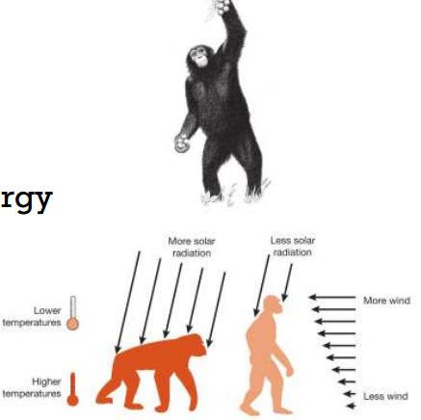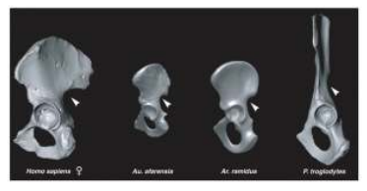

**A. kadabba**

- 5.2-5.8mya

- Primitive and derived dental traits

- Toe bone suggests bipedalism

- Canine sharpens against premolar

**Advantages of Bipedalism**

- **Evolved among arboreal Miocene apes as a feeding adaptation and was retained within hominins**

- Apes would use feet to grasp multiple small branches to support bodyweight and used hands for balance and grasping food items 🡪 Although a. ramidus specimen had monkeylike limb proportions which doesn’t fit with this theory.

-**Allows efficient harvesting of fruit from small trees**

- Studies have shown chimps rarely walk bipedally but stand bipedally to harvest fruit from small trees 🡪 allows for use of both hands

-**Erect posture**

- Allows for hominins to keep cool (see pic)

-**Leaves hands free to carry stuff**

- Quadrpeds have to carry things in their mouths 🡪 bipeds don’t.

- Carry larger portions of food for longer distances

-**Saves energy**

- Reduces heat stress and overall energy usage in many different ways.

**Hominin Diversification**

- Proliferation of homnins occurred approx.. 4-2mya in Africa

*Australopithecus*

- Au. Anamensis, au. Afarensis, au. Africanus, au. Garhi, au. Sediba

- Small bipeds, teeth, skull and jaws 🡪generalized diet

*Paranthopus*

- P. aethopicus, P. robustus, P. boisei

- Similar to Australopithecus from neck down

- Massive teeth + jaws - heavy chewing of tough plants

- powerful jaw muscles

*Kenyanthrpous*

- K. platyops

- Flattened face, small teeth

*Homo*

- First members of this genus likely coexisted with several other homnin species in East Africa

- Large brains and smaller teeth than hominins

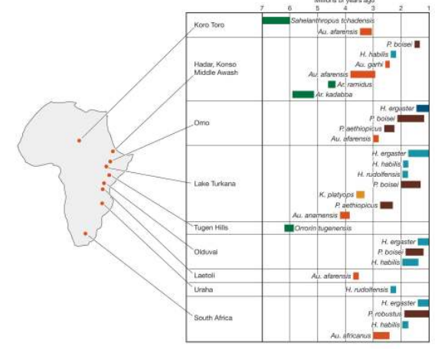

**Au. Anamensis**

- Existed between 4.2-3.8mya in Kenya/Ethiopia

- Bipedal, but had a more ape-like skull than later australopithecines

- Tibia, numerous teeth, humerus

- Bipedal from shape of tibia

- Large molars, thick enamel, small canines, knee + ankle joints are more human

- Ear holes, chin + dental arcade more primitive.

- Lived in a grassy, woodland habitat

**Au. Afarensis**

- 4 to 3mya 🡪 Lucy

- Woody grassland habitat

- Quite apelike in skull and dentition - Small brain, powerful chewing capacities; small endocranial volume

- Body-size sexual dimorphism

- bipedal based upon spine, pelvis, knee ankle and foot

- Some tree climbing abilities based on scapula and digits

- Bigger ones were 5ft tall

**Subnasal Prognathism**

- Front of the face below the nose is pushed out

**Diastema**

- Space between upper canine and lower incisor that accommodates the lower canine

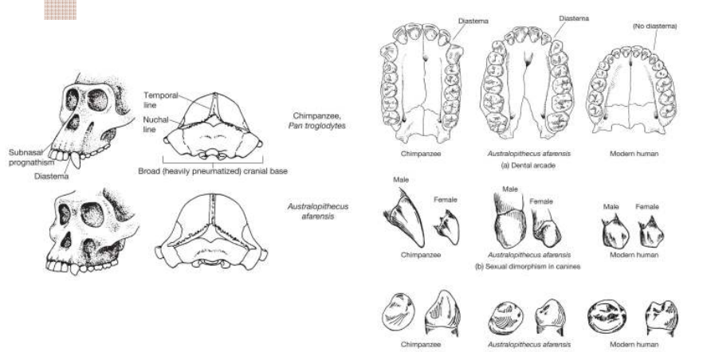

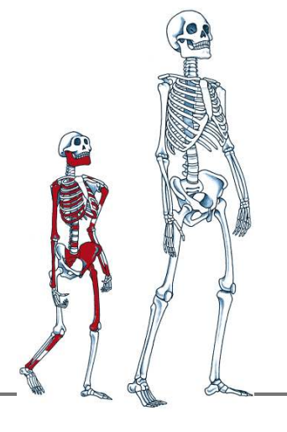

**Dikaka Child Selam**

- 3.3myo 3yo Ethiopian female

- Bi-pedal tree clinber

- Had hyoid and slower brain maturation

**Au. Africanus**

- 3 - 2.2mya in South Africa cave deposits

- Woody grassland area

- bipedal, rapid tooth development

- Pronounced sexual dimorphism in canine and body size.

- Exhibits derived traits that don’t appear in modern humans 🡪 food processing… mpremolars and molars are quite large, enamel is thick, lower jaw is large, face heavily buttressed

- Unlike humans and like chimps 🡪 developed rapidly

***Taung Child***

- Formane magnum - bipedalism

- Small canine

- Challenged large brain first idea

- Bipedal, rapid tooth development

**Enamel Development n stuff**

- analyzing dental enamel and load bearing properties of the facial skeleton provide clues about what kinds of food africanus ate

- Age at which teeth erupt 🡪 a great predictor for age of sexual maturity, age of first reproduction and general life span.

- rate at which enamel developed = rate at which they evolved overall

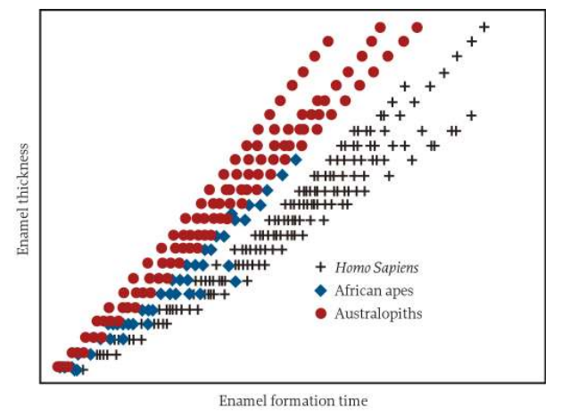

**Au. Garhi**

- East Africa, Ethiopia, 2.5mya

- Small brain, sagittal crest (thin of bone around centerline of skull), large teeth

**Au. Sediba**

- Malapa Cave, South Africa, 2-1.8mya

- Approx 1.3m tall

- Small brain, small teeth, less post-orbital construction than africanus and garhi

- Long arms with primitive feet

- Derived pelvis and hand traits

**Paranthopus**

**P. aethiopicus**

- Lake Turkana, Northern Kenya, 2.5mya

- Sexually dimorphic

- Enourmous molars, lower jaw very large, overall a massive chewing apparatus

- Huge cheekbones and zygomatic arches

**Temporalis Muscle**

- Has an enlarged surface area of bone for this muscle that works the jaw

**P. robustus**

- Found in South Africa 1.8-1.0 mya

- Cranial and dental adaptations for heavy chewing

- Bipedalism

- Extended growth in males; sexual dimporhism in body size

- Small brains,

- Relied on plant materials that needed have chewing 🡪 explains large chewing apparatus

**P. boisei**

- 2.2mya, East Africa, extinct by 1.3mya

- “Robust robustus”

- larger body and molars than P. robustus

- Ate seeds, tubers, roots

**Kenyanthropus**

**K. platyops**

- East Africa, 3.5-3.2mya

- Molars substantially smaller than those of any other hominin except for au. Ramidus.

- Broad + flat face, small brain, *small* molars

- Features different from australopithicines and paranthropids… features not found in any other genus

**Hominin Phylogenies**

- Sorted homnins into a phylogeny using derived and ancestral traits such as heavy chewing, large teeth + sagittal crest, features of the bottom of the cranium.

- Just because we don’t have a lot of evidence doesn’t mean we can’t understand human evolution.

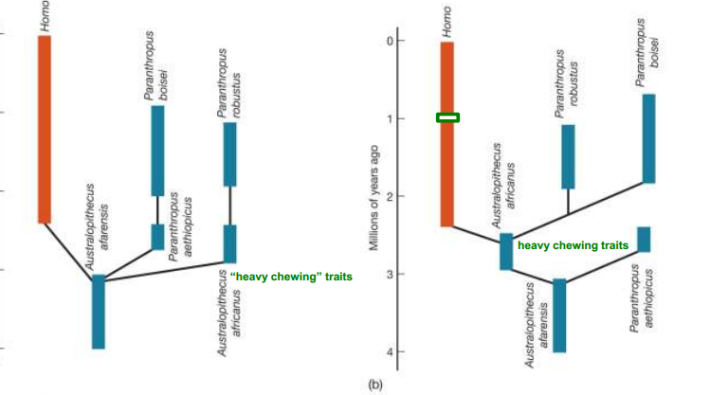

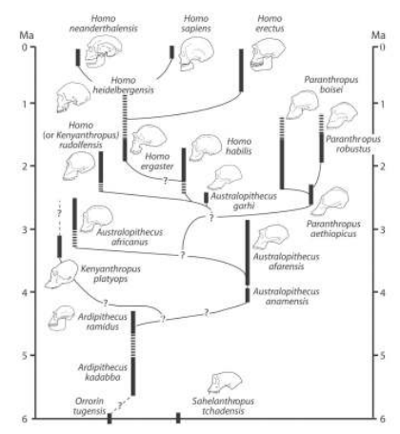

TL; DR